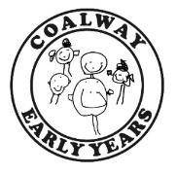
Playgroup News – Friday 16th October 2020

Hello Everyone,
Here is a summary of some of our learning at playgroup this week. Don’t forget to visit Tapestry for more information and photos!
Penguins room – the children have been talking about road safety and the importance of staying safe when they are out and about with their adults. We had a practice out in the school grounds, learning how to ‘stop-look-listen’ and safely cross the road, wearing our hi-viz vests and with Rachel being the ‘lollipop lady’! Please have a look on Tapestry for lots of photos and more information. We have continued to talk to the children about Autumn and they have had the opportunity to explore lots of Autumn ‘treasures’ such as coloured leaves, acorns, conker cases and cones. The children loved exploring the textures and using lots of varied vocabulary to describe the items.
Squirrels room – the children have been very interested in learning about Halloween – a theme we will be continuing next week! They continued to explore the pumpkins, including making faces with stick on items, and we made some spooky ghosts using cotton wool. Also, we made bread rolls and salt dough this week, as well as enjoying lots of singing, dancing and action rhymes.
Outdoor play – outside it has been a little cold but that doesn’t stop the fun at Coalway Early Years! The children have enjoyed outdoor art and craft with playdough and painting, small world play with trains, cars and a realistic dinosaur world, role play in the outdoor playhouse, and lots of racing and chasing games. Problem solving and large scale construction using the ‘loose parts’ is always popular and this activity teaches the children to experiment with their ideas, change strategies and persevere to achieve their goals.
Small groups – in their small groups this week the children in pre-school have been using ‘Numicon’ to practice their number, counting and problem solving skills, while younger children practice their listening/speaking/understanding skills through puzzles and concept games.
Ideas for home
‘Potion Making’
With Halloween coming up you may like to have a go at making ‘witches potions’ at home with your child.
You will need:
A large tray or table covered with a washable cloth
Containers, jugs, pots, utensils (such as spoons, ladles, potato mashers, funnels and sieves)
‘Ingredients’ such as coloured water (with food colour or safe paint), bubbly water (use mild hand soap or baby bath), shaving foam, sprinkles, glitter, food items such as flour/cornflour/porridge oats/cooking oil

Allow your child to experiment and mix the items. This activity helps to develop new vocabulary, maths concepts (measuring, comparing, counting, weighing), imagination and physical development (pouring, mixing, whisking, using utensils such as ladles and funnels).

ADULT SUPERVISION IS ESSENTIAL!
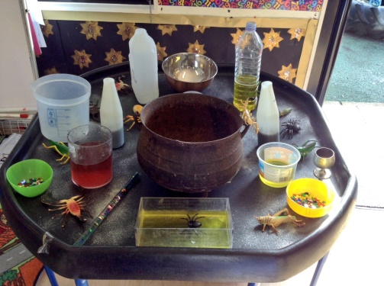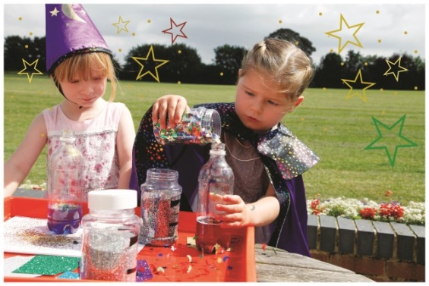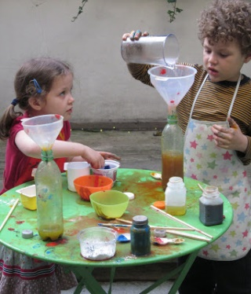
Thank-you
A massive thank-you to all of you who brought in items to support ‘Coalway Infant School’s’ collection for the Forest Foodbank – there was so much lovely stuff which will go a long way to helping local families in need! Thank-you also to those of you who have brought in donations towards our snacks for the children, including Jasper and Mel who brought in some yummy home-made jam today!
Another ‘Thank-you’!
We would also like to say a big thank-you to you all for coming to playgroup wearing face coverings – we did not want to take this step but felt that it was the right thing to do with the rising infection rate across the region. We really do appreciate your support and understanding.
School Admissions
We can’t quite believe that we are already talking about this but we have today received information from Gloucestershire County Council about deadline dates for school admissions for all children who will transition to primary school in September 2021. By mid-November you should receive a letter and information pack if your child falls into this category from the local authority – if you have not received this by the beginning of December you should contact Shire Hall on 01452 425407. The deadline for making your application is 15th January 2021 – it is essential that you get this in on time to indicate the school selection of your choice. If you have questions about this process please do not hesitate to email us and we will give you a call to discuss.
Dates for the diary
- Monday 19th – Wednesday 21st October – optional fancy dress for Hallowe’en
- Wednesday 21st October – end of Autumn term A for children
- Thursday 22nd/Friday 23rd October – INSET days
- Monday 2nd November – start of Autumn term B
- Thursday 5th November – Annual General Meeting
- Friday 15th January – deadline date for school applications
There will be no ‘Playgroup News’ next week so we would like to take this opportunity to wish you all a lovely, safe half-term break and ‘Happy Halloween’!

