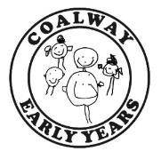
Playgroup News – Friday 23rd April 2021
Hello Everyone,
We hope you all had a fantastic Easter holiday and that the Easter bunny visited your houses! During the Easter holidays, the staff team came in to work their magic on our outdoor area and give it a well needed refurbishment and update – we hope you like the new look! With our refurbished mud garden and outdoor learning environment, and new gardening area we are very excited about the new opportunities this presents for providing some fantastic learning for your children this term.
See our Facebook page for photos of our newly refurbished outdoor areas.
Learning this week

This week in playgroup the children have been engaging in lots of lovely learning, which has included:

- Exploring the newly refurbished garden area with lots of exciting experiences including mud garden, large sandpit, gardening, large scale painting and art activities including chalk on our huge boards, water play, ‘ice-cream shop’ role play
- Introducing our new Story-Making text – ‘The Very Hungry Caterpillar’, and observing the progress of our very own live caterpillars
- To extend our learning about ‘life cycles’ the children have visited the pond in the school grounds to look for tadpoles
- Practicing counting and number recognition

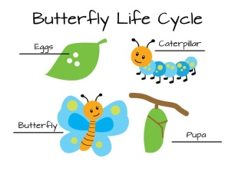
Don’t forget to check into Tapestry for more information, pictures and observations about our activities!
n’t for
Easter Fundraising
Thank-you SO much for supporting our Easter fundraising activities – we raised nearly £500 which is amazing! Some of our fundraising funds will be used to help us further develop our gardening area, including buying new gardening tools for the children and some plants.

Information Board for Parents/Carers

Please note our new information board in the outdoor area (bottom of Penguins ramp) where we will regularly be posting information and updates. Current information includes a request for Penguins parents/carers to please provide a small PE kit (shorts, T shirts, trainers – not new kit please as this may get soiled!), a request of parents/carers to collect playgroup children on time (before school pick-ups if necessary) as children become distressed if they are picked up late, and a reminder to parents/carers particularly of our Squirrels group of the need to provide PLENTY (at least three sets) of spare clothes for changes.
New Baby and Toddler Group – ‘Coalway Cubs’

As you may have seen from our Facebook posts, we are delighted to announce the introduction of our new outdoor baby and toddler group called ‘Coalway Cubs’. This group takes place on a Tuesday morning 9.30am to 10.30am, in our outdoor play area. Sessions are currently full up until the end of this school year, however if you are interested in this group for younger siblings, friends or family members please contact us via email and we can add you to the waiting list.

IMPORTANT REMINDER - Severe Peanut Allergy Alert

We have a new child starting with us who has a severe peanut allergy, and is also allergic to a number of other foods and materials. Our playgroup is a ‘nut-free’ zone but please be extra vigilant about items sent in children’s lunchboxes. Please check the ingredients to make sure that no items contain nuts or state that they are ‘handled in an area that may contain nuts/peanuts’. A letter has been sent home to all parents of Squirrels children.

Announcement

Before Easter our Manager, Marie Ridgway, sent a letter out to all parents/carers announcing that she will be leaving the playgroup this month. Marie’s last day will be Friday 14th May, the Management role will be taken over by Sarah Rawlings and Carly Halford as joint Managers, with Rachel Hale being promoted to Deputy Manager.

Diary dates:
Bank Holiday (playgroup closed) – Monday 3rd May
Half term – Monday 31st May to Friday 4th June

