Welcome to ‘Coalway Early Years’ 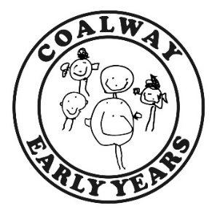

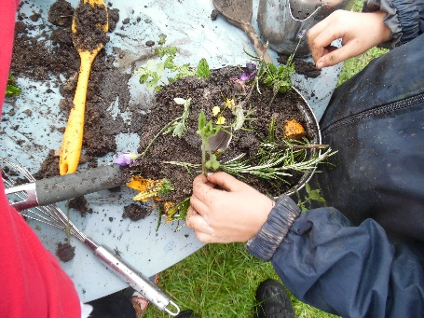
​Here at Coalway Early Years we offer outstanding education and care for children aged 2, 3 and 4 years. We aim to provide a safe and nurturing environment where children are supported to reach their full potential. We strive to support every child in our care, encouraging them to become skilled and able communicators, resilient and independent learners who have confidence in their own abilities.
We encourage and reward the children’s willingness to try new things, Practitioners encourage children to ‘have a go’ to enable them to feel pride in their attempts and to develop an ability to learn from their failures.
Our ‘family’ atmosphere enables children to settle quickly with Practitioners supporting their emotional well-being exceptionally well; children develop a sense of security which allows them to excel in all areas of their development.

We are open term time, 38 weeks of the year following the term times and inset days in line with Coalway Infant and Junior Schools. The setting is a committee run, non-profit making charity and is registered with Ofsted under the Children’s Act 1989. At our last Ofsted inspection on 9th May 2018 we were awarded ‘Outstanding’ in all areas.

We have two base rooms – Our pre-school room (‘Penguins’) room is for our children in the final year of playgroup prior to starting school, and our starter room (‘Squirrels’) is for our 2 year olds and younger 3 year olds. However, due to the number of children on role from September 2021 we will be operating from one room (Penguin Room) meaning all children aged 2, 3 and 4 will be in a mixed aged room together, please be assured that this will have no impact on the high quality of care and provision that your child receives. We will be using the ‘Squirrel’ room as a ‘break off’ room at times to ensure we continue to meet the individual needs of all children. These times may include small group times, circle times and story times.
Once numbers of children on role begin to increase we will then look at moving back to operating from both rooms, however we will inform you in advance if this was to happen.
We provide a large, open plan environment with 'zoned' areas that focus on the various aspects of the curriculum, for example art, mark-making, and construction. In addition we provide quieter, more enclosed spaces for cosy, reflective learning opportunities such as role-play, conversation and storytelling. Our large outdoor play area provides fun and challenging teaching and learning opportunities that include a "mud kitchen", large sand-pit, gardening area, outdoor creative arts area, and "loose parts" to promote problem solving and construction on a larger scale.
We have our own Nature Area in the school grounds and are very lucky to also be able to access a wide range of other environments and experiences provided by the schools - this includes use of the school hall and field for P.E, a large 'trim-trail', and playground area for riding bikes.
We balance our daily routines between extended periods of child-led play to help the children develop their own ideas and interests, and adult led experiences that enable us to offer more focused teaching activities - these include 'Story-Making' sessions, small group activities and Circle Times.
Our aim is to provide stimulating, open-ended activities that promote social interaction, independent learning and critical thinking skills. We are continuously evaluating and improving our learning environment to ensure we maintain outstanding teaching and learning so that every child attending is able to fulfil their potential.
Session Times

We are open Monday to Friday during term-time and you may choose from full day sessions (9am to 3pm) or half day sessions (9am to 12pm; 12pm to 3pm). We also work closely with ‘Coalway Kids Club’ who offers extended care for children from the term after their third birthday, supporting families who need ‘wrap around care’.

Daily Routine

A typical day at ‘Coalway Early Years’……
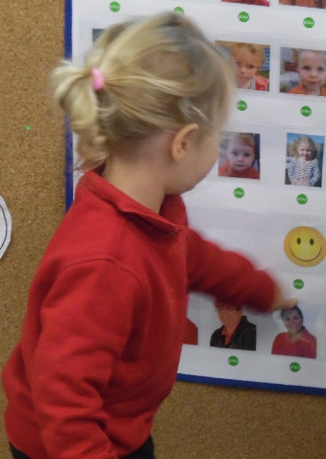
09.00 Welcome and registration
09.15 Indoor play session
10.00 Snack time
10.30 ‘Free-flow’ play session between the indoor and outdoor areas. During this
time some children may join with the adults for small group activities
11.40 Brief tidy up followed by a whole group activity
12.00 Lunchtime and changeover
13.00 Whole group activity such as ‘Story-Making’
13.15 ‘Free-flow’ play session between indoor and outdoor areas
14.30 Big tidy up time!
14.45 Refreshments followed by a whole group activity
15.00 Home-time.

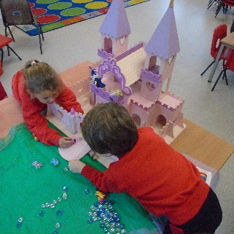
Curriculum

We deliver a broad, stimulating, engaging and enriched curriculum that ignites children’s love of learning, sparks their imagination, develops thought-provoking responses and fosters a sense of awe and wonder. The Educational Programmes from the Statutory Framework for the Early Years Foundation Stage (DfE, 2021) underpins our core teaching and learning principles with a well-balanced approach of child initiated learning and adult led activities.

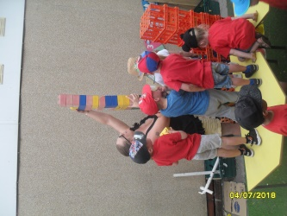
Each term the children are ‘hooked’ into a broad ‘I wonder’ theme topic which enables Practitioner’s to nurture their natural curiosity where they are able to search for meaning and ask numerous question which then drives them into a deeper engagement of learning. The children are empowered to discover more, to explore and to become engrossed in learning that is self-directed. Practitioners enable children to maximise their learning through free-play explorations, focused explorations and enquiry-based learning opportunities.
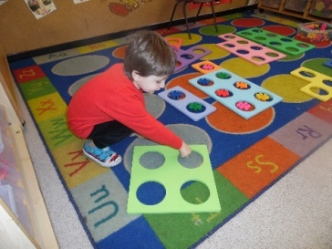
Our curriculum allows children to explore their own ideas, to test them and to push them to the furthest extremes, allowing them to develop skills such as concentration, resilience, perseverance, collaboration, communication and so much more. Children are central to the setting’s planning cycle; they share their thoughts, feelings and ideas with Practitioner’s and this is documented in our ‘floor books.’ They are able to record their learning, goals, aspirations and achievements; they recall their experiences and take ownership for their own education which in turn empowers them to become independent learners.
Assessments and Planning

The Early Years Foundation Stage (EYFS) is being reformed and there is a new EYFS framework that all schools and settings will follow from September 2021. These national changes have been made to better support all young children’s learning and development. Practitioners will now be spending less time on large amounts of written observations and assessments for evidence collection, enabling them to spend more time supporting and engaging with the children and their learning and development needs.

Practitioners will observe the children engaged in a variety of activities, both child-initiated and adult-led, in order to make professional judgements about their stages of development within the different areas of the curriculum, Practitioners will use their experience and knowledge to monitor if a child’s learning and development is on track for their age. Each half term, Practitioners will have ‘Pupil Progress Meetings’ where they will complete formative and summative assessments to monitor your child’s progress.

Practitioners will work in close partnership with you, sharing these observations, highlighting your child’s achievements and also discussing any concerns if necessary.

We use an electronic learning journey for each child using the Tapestry assessment tool. Upon registration we will assist you with setting up login details for this tool. This system is completely secure and cannot be publicly viewed. Parents/Carers and other family members are encouraged to contribute to this learning journey by uploading comments and photographs of things the children have been doing at home.

Staff

All the staff at Coalway Early Years are suitably qualified and highly experienced. All staff hold certificates in Child Protection training and Paediatric First Aid. We are committed to the continuing professional development of our team, and staff members regularly attend external and internal training, meetings and forums to keep their knowledge and practice up to date. Full information about our staff team and structure can be found on our parent notice board and website.

Key Person Approach

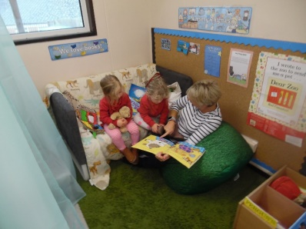
At Coalway Early Years we value strong, supportive partnerships with the children and families who use our service. When your child joins our playgroup, they will be assigned a key adult/s who will help to settle them in and spend time talking with you about your child’s needs, interests and abilities. They will act as your continuous main point of contact for any advice, support or information you may require whilst your child attends our playgroup. Your child’s key person/s will introduce themselves to you at the earliest opportunity after your child starts playgroup.

Committee

Coalway Early Years is a committee run, non-profit making charity. The committee are a group of volunteers, including parents, who hold regular, informal meetings to discuss the running of the group, help to make decisions based on our improvement plan, and oversee the playgroup budget. If you are interested in volunteering for this role we invite you to contact Marie Ridgway, our Manager. We are committed to safeguarding children and as such all volunteers are required to undergo a DBS check.

Partnership with Parents/Carers

Developing close, supportive partnerships with the parents and families of the children who attend our setting is a key part of our practice. At the enquiry and registration stage we will work closely with you to ensure we obtain detailed information about the needs and interests of your child and your aspirations for them.

We encourage parents and families to take an active part in supporting our playgroup. As a committee run charity, we rely heavily on fundraising to boost our income and run several activities linked to this throughout the year.

Some of the activities we currently offer to support our partnership with parents are:

- Free introductory sessions – we offer the opportunity for you and your child to visit the setting prior to starting with us and to join us for a short ‘taster’ sessions.
- Parents consultation meetings/open days – these may be linked to information sharing about our practice or curriculum; to discuss your child’s development, and to discuss transition to school when the time comes.
- Support for parents of children with special education needs and/or disabilities – our SEND Coordinator, Sarah Rawlings, will support you with making the right decisions for your child, sign-posting to other agencies, and creating plans for targeted support.
- Family Support – Sarah is also an experienced Family Support Worker and can help parents with a variety of issues, such as sign-posting to other agencies and support with routines at home such as toilet training and managing behaviour.
- Sharing of information – we ensure that you have access to lots of information about our day to day practice and your child’s development through notice boards, a weekly newsletter, our website, Facebook page and your personal access to your child’s electronic learning journey via Tapestry.

Funding and Fees

Your child may be eligible for childcare funding according to their age and your circumstances. More information can be found regarding this by visiting our website. Alternatively you can email our Finance Officer, Jo Young, at ceyfinance@outlook.com who will be happy to help you and answer any questions. Our fees for non-funded places are £4.95 for 2 year olds and £4.70 for 3 and 4 year olds.

Snacks and Lunches

Mid-morning the children are offered a healthy snack consisting of a choice of fruit and/or raw vegetables, a savoury item, and milk or water to drink. Please provide a named bottle of water for your child so that we can ensure drinking water is available to the children all day.

If your child stays for lunch you must provide them with a healthy choice lunchbox and a suitable drink. Please note that we do not permit fizzy drinks, chocolate or sweets in children’s lunchboxes.

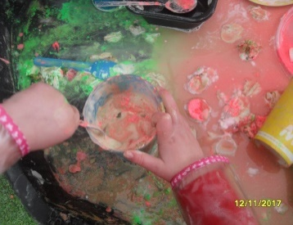
Clothing

We do have an optional uniform which can be purchased online via www.myclothing.com .

Please bear in mind that in line with the EYFS curriculum we actively encourage messy play that may include using sand, water, mud, paint, glue and other items – as such PLEASE do not send your child to playgroup in their best clothes! Although we do ask the children to wear protective clothing for messy play, inevitably at times they will get paint, mud, water etc on their clothes. We encourage your child to take part in these types of activities and we ask parents and carers to be supportive of this.

NB: Please provide a NAMED bag of NAMED spare clothes to be left at playgroup!

Please also ensure that your child comes to playgroup equipped for the weather as follows:

Autumn/Winter | Spring/Summer | Wet Weather
- Warm layers  - Warm, waterproof coat  - Hat, scarf, gloves (if very cold) | - Layers  - A light waterproof coat for showers  - Sun hat  - A named bottle of sun-cream | - A named pair of wellies  - We provide full waterproof cover-ups for when the garden is very wet or muddy.

Other equipment your child might need or wish to bring

- Nappies/pull-ups – if your child still wears nappies or pull-ups, we ask you to provide spare nappies, wet wipes and disposal bags in your child’s spare clothing bag. At the appropriate time, your child’s key person will work closely with you to support you and your child with toilet training.
- Medicine and medical equipment – if your child has a medical condition that requires treatment during their time at nursery (for example, asthma, skin conditions) you will need to inform us and complete appropriate medical permission forms. Asthma inhalers and any other on-going medication must be given to your child’s key person NOT left in their bag or drawer. If they require other periodic medication we will ask you to complete a permission form.
- Toys and comforters – IF your child requires a comforter/ toy to help them to settle we will allow them to bring these along to playgroup, however we cannot take responsibility if these items are left behind or lost. Key Persons will work with you to support your child with settling.

Policies

All our policies, which ensure that we abide by legal and statutory requirements and underpin the procedures of our practice can be viewed at the setting or via our website.

Further information

For more information please visit our website at www.coalwayearlyyears.co.uk or our Facebook page.
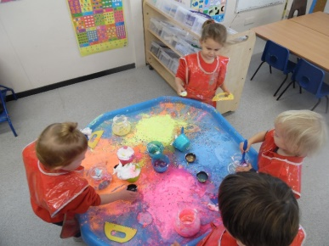
If you have any queries please do not hesitate to get in touch. We look forward to welcoming you and your child to ‘Coalway Early Years’!

