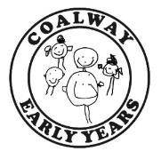
Playgroup News – Friday 12th March 2021
Hello Everyone,
It has been so wonderful to welcome most of our lovely playgroup family back to nursery this week! The children have been amazing and have slotted straight back into the playgroup routine with no fuss or bother – you should be extremely proud of your little ones for coping with all of these changes so brilliantly!
Learning this week

This week in playgroup the children have been engaging in lots of lovely learning, which has included:

- Lots of group play outdoors, constructing with the loose parts, sand play, small world play and lots of imaginative play with some large cardboard boxes – we converted the outdoor playhouse into an ice-cream shop as this was a popular theme with the sand!
- Making models using recycled materials – lots of problem solving, language and mathematical skills
- Mark-making with letters and names in Penguins, and in rice on the mirror tray in Squirrels
- Listening to CDs and practicing action rhymes, as well as singing familiar songs and nursery rhymes
- Playing on the soft play equipment in Squirrels
- In both rooms, making cards for Mothers and special people in our lives
- In both rooms the children have loved their Story-Making texts – in Squirrels, ‘Brown Bear, Brown Bear’ and in Penguins ‘We’re Going on a Bear Hunt’.

Don’t forget to check into Tapestry for more information, pictures and observations about our activities!
n’t for
Easter Fundraising

This year we have the following fun activities planned to help us raise some funds to enable us to continue to improve our environment and resources (see below for our current fundraising focus). A pack has been sent home this week with all the information about these events:

- Easter Raffle – Raffle tickets are £2 for five tickets, please return tickets and money to playgroup by Friday 26th March as the raffle will be drawn on Monday 29th March. We now need prizes – Easter eggs or chocolate gifts, new gifts and toys. Thank-you!
- Sponsored egg/carrot – please complete sponsor forms and return with money by Wednesday 31st March. There will be a small prize for every sponsor form received with a special prize for any child who collects over £20!
- Easter Hat competition – this is £1 to enter, anything goes! Please send your child’s hat into playgroup with them for us to take a photograph. The children will vote for their favourite at the end of term and there will be a prize for the winner from each room!

Labelling Belongings
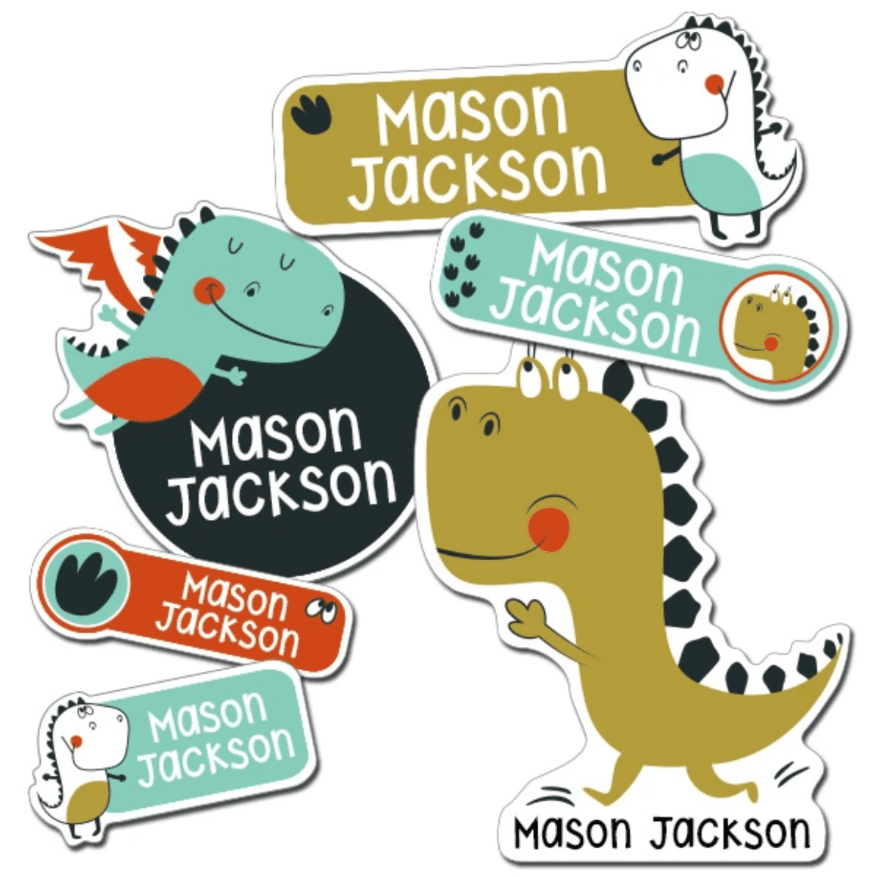
Please can you ensure that EVERY item of clothing either worn or left at playgroup, and all belongings are clearly labelled with your child’s name! This includes coats, change bags and their contents, wellies, water bottles, lunchboxes and so on!
Red Nose Day

Next Friday, 19th March is Red Nose Day, raising money for the Comic Relief charity. If you child attends that day we are inviting them to have a ‘Mad Hair Day’ – get creative with those hairstyles!! – to help us celebrate the day and learn about the good causes supported by the charity. We will NOT be asking for donations, but if you would like to support the work of Comic Relief you can find further information by visiting their website at https://www.comicrelief.com/rednoseday/

Diary dates:
- Red Nose Day – Friday 19th March – ‘Mad Hair Day’!
- End of Spring term B – Thursday 1st April
- School Allocation Day – Friday 16th April
- Start of Summer term A – Monday 19th April

