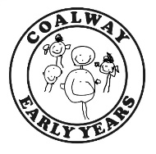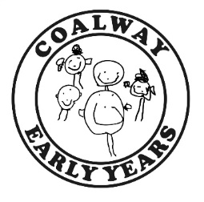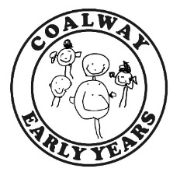

**It’s All About Me!**

I live with...

Please complete this form on behalf of your child, we use this information to help your child settle in and it informs us of their ‘starting point.’

My Name is...

I like to be called ...

I am…

(Age in months)

My start date is…

I have some pets and they are…

When I am tired I will…

You can help me by …

When I feel upset I…

These actions or comforters help calm me down…

These are my favourite things I like to play with at my house…

My parents/carers would describe me as…

*e.g. confident, shy etc.*

I like to drink milk and water in a

Bottle / lidded cup/ open cup

The things I can do by myself are...

*e.g. use the toilet, dress myself, wash my hands.*

Things I like to play with are…

Paint / Sand / Water / Messy Play

I communicate my needs through

Gesture / babble / words / sentences

My favourite nursery rhymes/ songs/ stories are…

My favourite things to eat are...

Things I don’t like are…

My Parents/Carers may also like to tell you more about me…