Playgroup News – Friday 26th February 2021
Hello Everyone,
It has been lovely to be back at playgroup this week and we are excited by the news that more children will be returning to us soon! This week the weather has been very nice and the children have had lots of outdoor play, visiting the Nature Area to put more seed in the bird feeders and look for signs of Spring, and enjoying playing in the garden – the children have particularly enjoyed playing together with our ‘sand kitchens’ and there has been some lovely language, social skills and imaginative learning on show! We welcomed some new children this week and they have settled in brilliantly!
Don’t forget to check-out Tapestry for pictures and observations of our activities in playgroup and for ideas to try at home!
Schools Re-opening March 8th 2021

As you know, the Government have announced that schools will be fully re-opening from March 8th 2021, and an email was sent out to all parents at the beginning of this week to find out your intentions regarding your child’s attendance at playgroup. Thank-you for all of your responses – it seems that the vast majority of our children will be returning to playgroup by that date. With this in mind, we will be returning to our two rooms with pre-school children based in Penguins Room and our younger children based in Squirrels Room. We do not currently have any plans to operate staggered drop off and pick up times, but please ensure that the following protective measures are observed:

- Face-coverings must be worn at all times on the school site
- From March 8th, the school will be operating a one-way system on site – please arrive via the main gates and leave via the Holcott Road exit
- Please observe social distancing on our path, and in the garden whilst waiting to drop-off or collect
- Please do not allow your children to run around the garden – they must wait quietly with you at all times
- Please use the hand sanitizer provided
- Please send a clean, named water bottle for your child each session

Home-Schooling

We hope that you have enjoyed the activities and learning ideas that your children’s key adults have been adding to your child’s Learning Journal on Tapestry. With the vast majority of our children returning to playgroup from March 8th onwards, we will now be reverting to adding observations about the learning your child is doing in playgroup. We will still be very grateful for any observations you share with us from home, and for any comments on the ones we share with you!
Thank-you so much to all those of you who have been sharing your activities from home on Tapestry, and for liking and commenting on our posts. We really appreciate the feedback!
Names Please!!

Please, please can you make sure that ALL your child’s clothes (including spare ones in their change bags), water bottles, lunchboxes and coats are clearly named – we have had some issues with not being to identify items that look the same – particularly difficult when it comes to playgroup uniform! Thank-you!
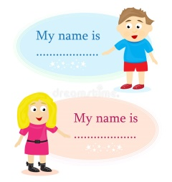

Mud Garden development

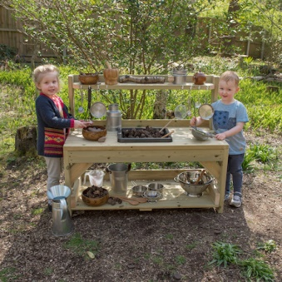
This week we have been very excited as work has begun on the development of our Mud Garden. A beautiful mud kitchen unit has been delivered, and the remodelling of the garden has also started. The new development will include a large digging pit for mud, a new giant sand pit, levelling of the garden and re-turfing, new mud kitchen units, a garden shed and welly store! We will post pictures soon on our website of the work as it progresses. This new area will provide a great range of learning opportunities for the children including social development, physical skills, language, practical maths skills, understanding of the natural world, use of imagination and sharing narrative with others, and problem solving. Watch this space!!

Please note that next Friday, March 5th, the Infant and Junior Schools are closing early for cleaning. We will be open as normal until 3pm however if you wish to collect your child early you may – please inform us when you drop off so that we can make sure your child is ready.
Diary dates:
- Schools re-opening – March 8th
- Red Nose Day – Friday 19th March – more information to follow
- End of Spring term B – Thursday 1st April
- School Allocation Day – Friday 16th April
- Start of Summer term A – Monday 19th April

